CST presentation
By Jesper Graungaard Bertelsen, AU-ID: au689481, Andreas Gutevall

Indholdsfortegnelse
CST presentation 1
Modelling ( Jesper ) 2
Software used ( Why / Why not ): 2
Structure and material assignment 2
Port location? 2
Simulation / Comparison ( Andreas ) 2
Discussion ( Jesper ) 5

Modelling ( Jesper )

Software used ( Why / Why not ):
The choice of software depends on what problem you are trying to solve. If you have some squared PSB, with some simple antenna structures, then great, CST might be able to optimize the structure for you. Giving it the sizes that’s been acquired prehand, one would be able to tweak / tune the parameters for better results.
For more complex structures, the difficulty of modelling might weigh more than the ability to tune the model. We made a model both by CST and also by a 3D model made from Blender. The flexibility within CST might have been lost, but modelling in Blender seemed much simpler and for us not using the flexibility part, 3D modelling in other software seemed as the way to go for our Meander Line Antenna.

Structure and material assignment
Some ground plane of size $\left(A, B, 0.05λ_{g}\right)$ for A and B being some custom chosen value, that makes for trenches next to the antenna patch.
Ground plane $\left(A, B, 0.05λ_{g}\right)≡PEC$
Dielectric plane $\left(A, B, 32mm\right)$ $≡FR4$
Meander antenna $\left(C, D, 0.05λ_{g}\right)≡PEC$
For C and D being the dimensions known for the meander setup, and for $C≫A, D≫B$, to make for the trenches. PEC, FR4, PEC for the material assignment for Ground plane, Dielectric plane and the Meander Antenna, respectively.

Port location?
The port is a discrete port having one point at the bottom left on the antenna patch, and the other diagonally down from the antenna patch, reaching the ground plane.

Simulation / Comparison ( Andreas )
H=32
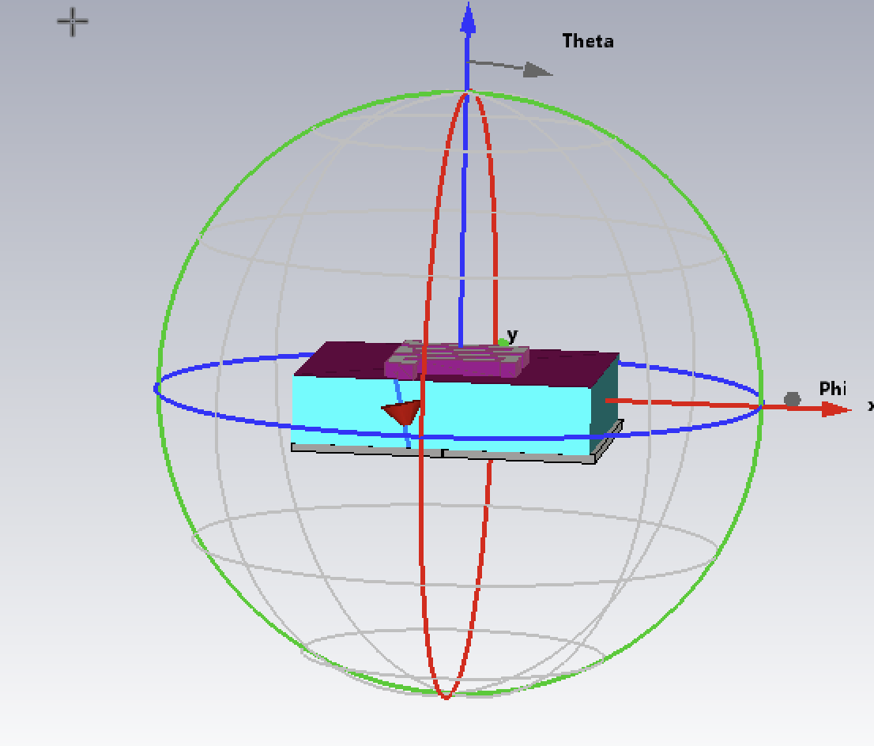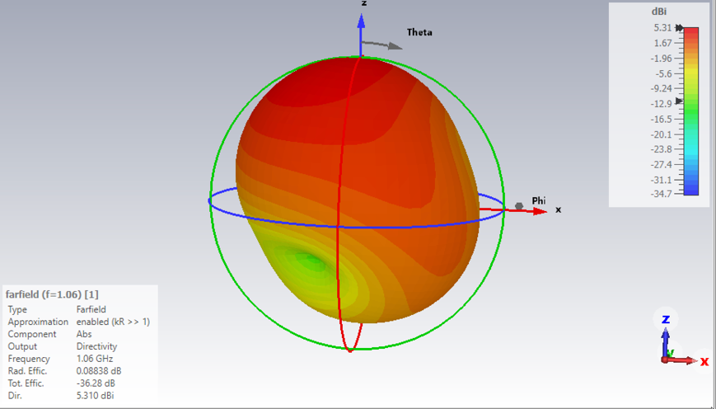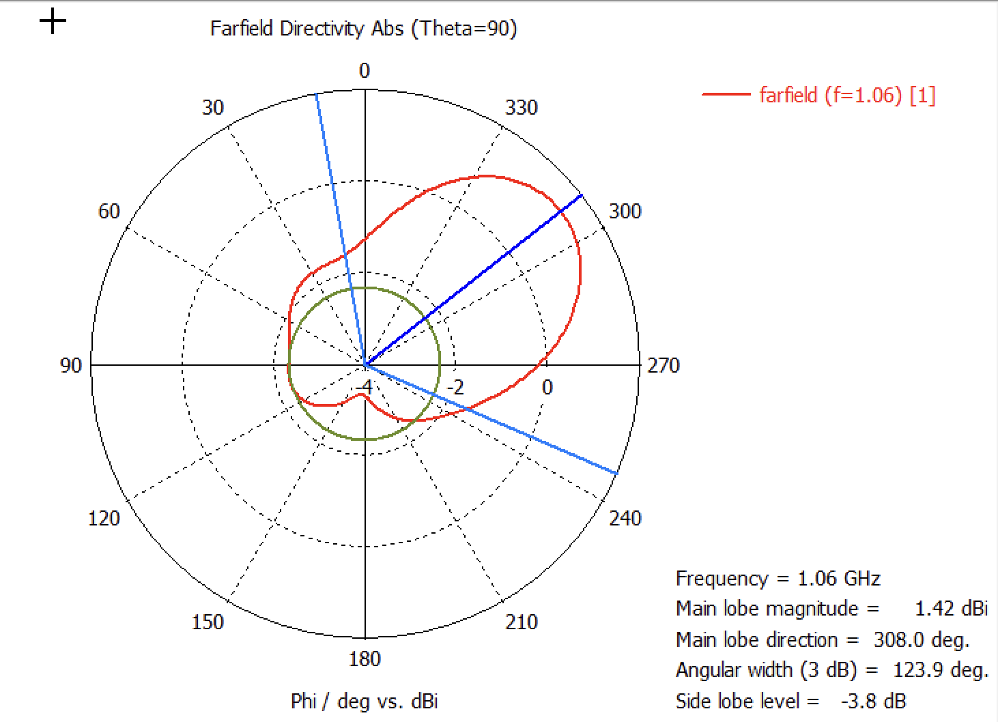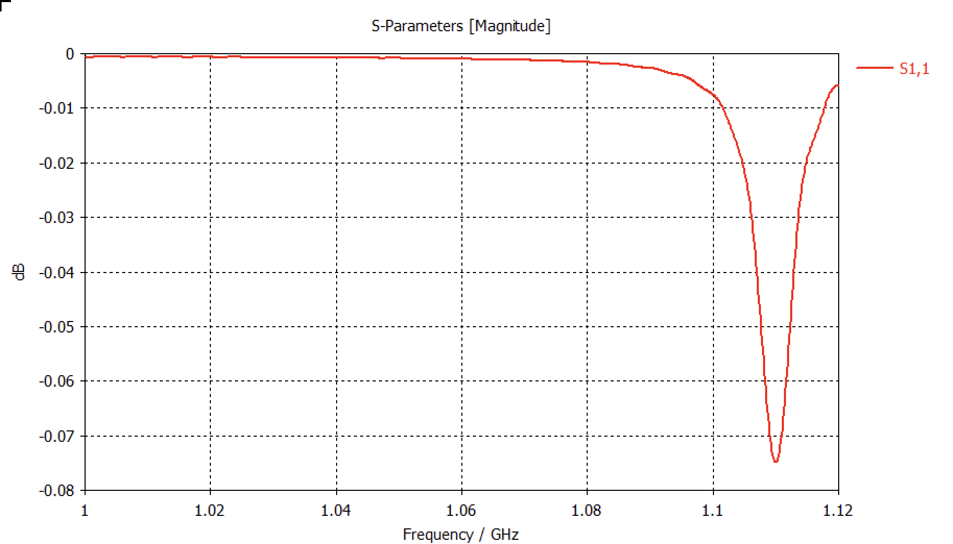
The directivity of this simulation is 5.31 dBi, which is an ok result compared with the papers calculated value of 6.29 dBi, since this is a realized simulation.
The calculated 3 dB width is 112 degrees, but the simulation gives 123.9 dB. This explains the lower value of directivity. The realized antenna has a wider 3 dB range, and therefore the directivity value is lower.
The resonance is close to the target of 1060 MHz, but the S plot shows that almost no power enters the antenna in this simulation. This leads to the total efficiency being –36.28 dB.
We did a new simulation, because this one didn't give results that we were satisfied with.
h=3.2
We started from scratch and made a new simulation, and also changed the substrate thickness to 3.2 mm, because 32 mm seems to thick for an antenna like this. This simulation ended up with better results, and without the power problems that we had in the first one.
The higher directivity value from the simulation is connected to the narrower E-plane, as seen in the table. The other results are close to the calculated values, by using the formulas in the paper.
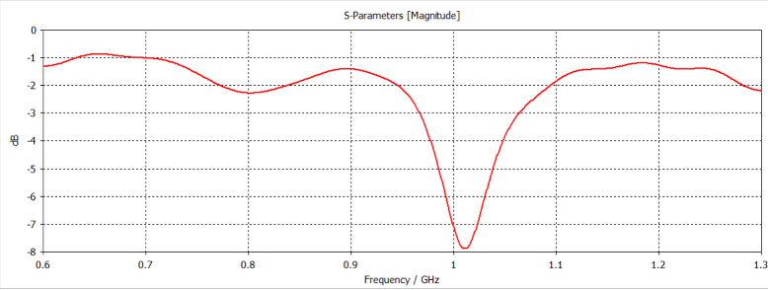
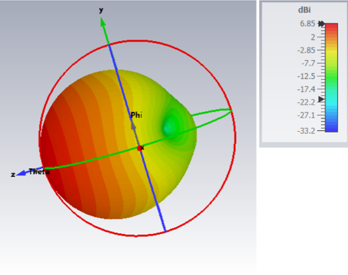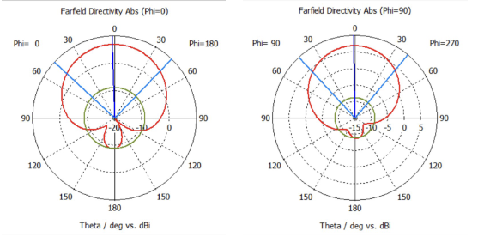
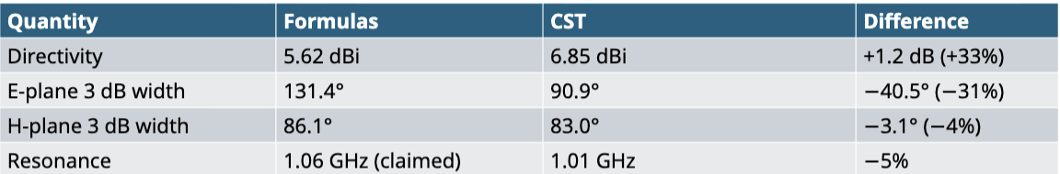
The thick substrate gave a wider 3 dB range and lower directivity value, than what was calculated by using the formulas.
The thin substrate gave a narrower 3 dB range and higher value of directivity, than what was calculated with the formulas.
Both simulations have a resonance that is close to the desired frequency 1060 MHz.
The radiation from the thin substrate simulation is more compact and focused.

Discussion ( Jesper )
While CST is a tool mainly for supplying simulations, they do have a 3D modelling engine, where one is able to make designs. By combining the simulation engine and the 3D modelling engine, tweaking and tuning becomes available, which gives incredible new ways of doing ones design.
CST is a tool mainly for supplying simulations, and even though the benefit of the integration between simulation and 3D modelling comes with great new possibilities, it comes with the limitation that simulation is the main focus of CST, and complex structures might be difficult to achieve, or atleast require a lot of time and effort. The Meander Line Antenna might have been on the edge of this complexity. It was possible, but could become tedious to setup and even though we managed to do the simulation completely in CST, we chose to progress with the imported version. All in all the process of getting simulations to work in CST wasn’t as much effort as trying to make a model based on approximations. But the articled showed the potential that, large computational engines aren’t required for making the calculations, and that approximating it given set formulars actually achieved somewhat of the same results.
That the setup was nonoptimal was known from the start, and it showed. Having set up the models for the meander line, we could then quickly change the parameter of h. Demonstrating, that a height of 32mm was too much, and hindered the design of becoming the best antenna, that it could become.

